**EXP NO:6**

**Aim:**

To demonstrate virtualization by installing a Type-2 hypervisor (VMware Workstation Player), creating and configuring a virtual machine with a host operating system (Linux/Windows).

### ****Software/Tools Required:****

* VMware Workstation Player
* ISO file of a Guest OS (e.g., Ubuntu or Windows 10)
* System with virtualization support (BIOS enabled)

### ****Procedure:****

1. Download and install VMware Workstation Player.
2. Download the ISO file of the guest OS (Windows or Linux).
3. Open VMware and create a new virtual machine.
4. Select the downloaded ISO file as the installer source.
5. Set the VM name, OS type, disk size, and memory.
6. Start the VM and install the guest OS.
7. Complete OS setup and restart the VM.
8. (Optional) Install VMware Tools for better performance.
9. Verify the VM is working with internet and basic apps.

**Result:**

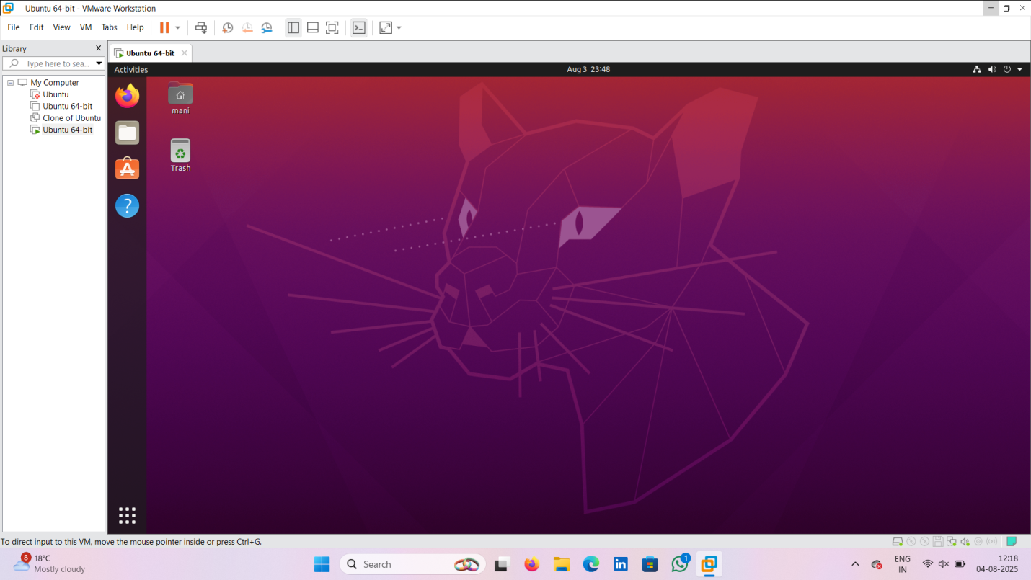

**EXP:7**

### ****Aim:****

To create a Virtual Machine with 1 CPU, 2 GB RAM, and 15 GB storage disk using Type-2 virtualization software (VirtualBox).

### ****Procedure:****

1. Download and install Oracle VirtualBox.
2. Download the ISO file of a guest OS (Windows/Linux).
3. Open VirtualBox and click “New” to create a virtual machine.
4. Set the name, OS type, and version.
5. Allocate 2 GB (2048 MB) of RAM.
6. Create a virtual hard disk with 15 GB size.
7. Attach the ISO file to the virtual optical drive.
8. Configure the processor to 1 CPU under system settings.
9. Start the VM and install the guest OS.
10. Complete OS installation and verify VM functionality.

**Result:**

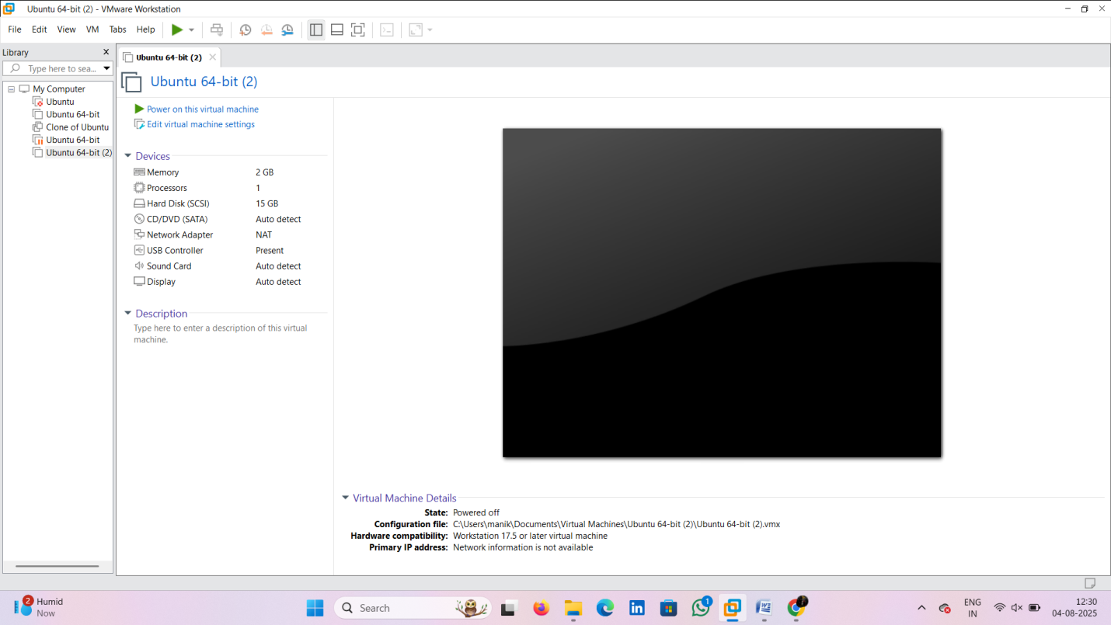

**EXP 8:**

### ****Aim:****

To create a virtual hard disk and allocate storage space using Oracle VirtualBox.

### ****Procedure:****

1. Open VirtualBox and click **“New”** to create a virtual machine.
2. Proceed with name, OS type, and version setup.
3. Choose **“Create a virtual hard disk now”**.
4. Select **VDI (VirtualBox Disk Image)** as the disk file type.
5. Choose **Dynamically allocated** storage.
6. Set the disk size (e.g., 15 GB).
7. Complete the VM creation process.

**Result :**

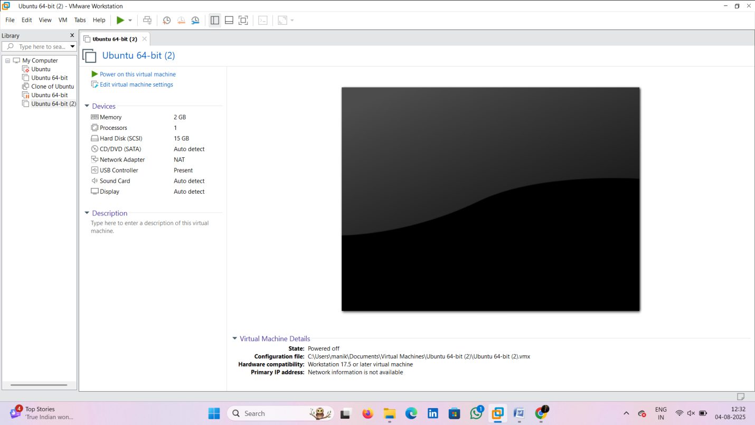

**EXP 9:**

### ****Aim:****

To create a snapshot of a virtual machine and test it by restoring the previous state or using a cloned VM in VirtualBox.

### ****Procedure:****

1. Open VirtualBox and start the target virtual machine.
2. Go to **Machine > Take Snapshot**.
3. Enter a name and description for the snapshot and save it.
4. Make changes in the VM (e.g., install software or modify files).
5. To test, go to **Snapshots** tab and restore the saved snapshot.
6. Alternatively, right-click the VM and select **Clone** to create a duplicate.
7. Start the cloned VM and verify it matches the snapshot state.

**Result:**

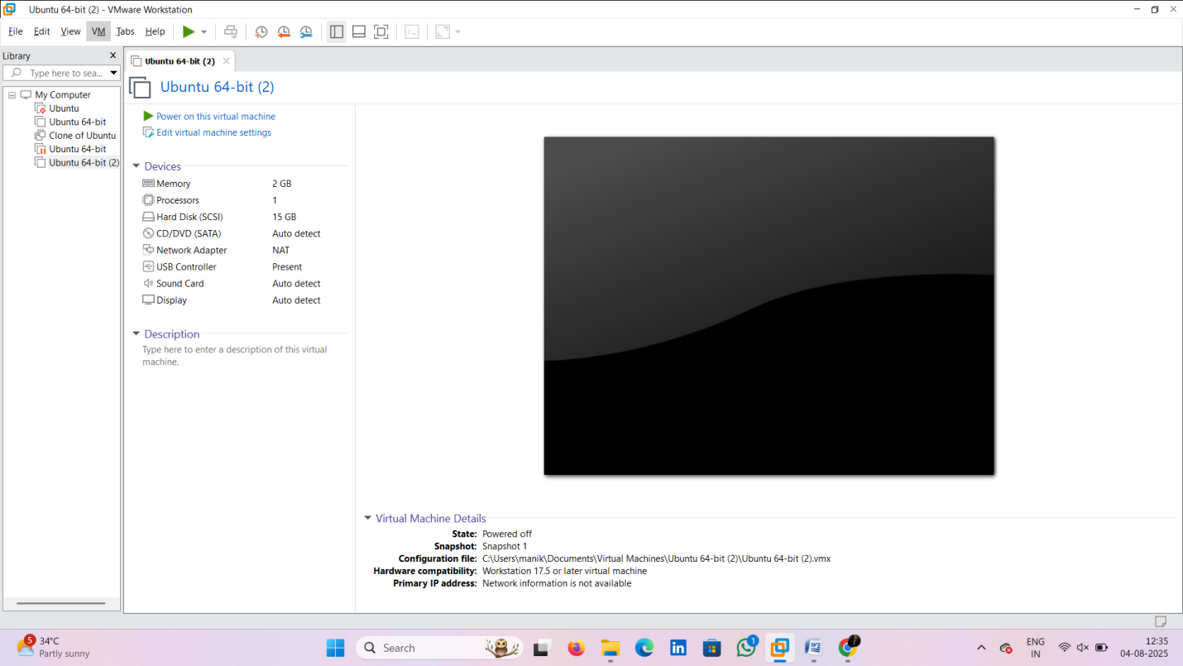

**EXP 10**

### ****Aim:****

To create a clone of a virtual machine and test it by loading and running the cloned VM using Oracle VirtualBox.

### ****Procedure:****

1. Open VirtualBox and right-click the VM you want to clone.
2. Select **Clone** from the context menu.
3. Enter a name for the cloned VM.
4. Choose **Full clone** and **Current state only** options.
5. Click **Clone** to complete the process.
6. Start the cloned VM from the VirtualBox Manager.
7. Verify the cloned VM boots and runs with the same configuration and data as the original.

**Result:**

